Assignment 1:

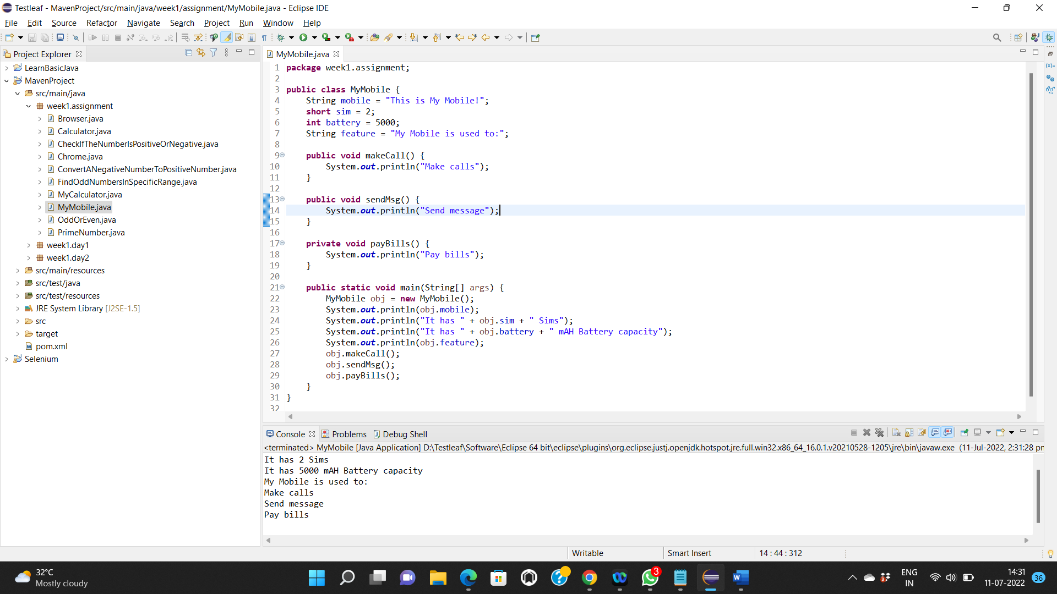

Assignment 2:

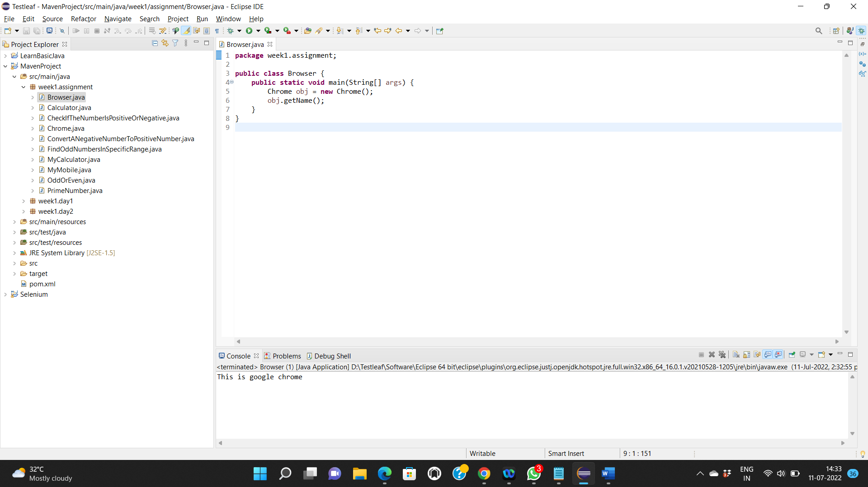

Assignment 3:

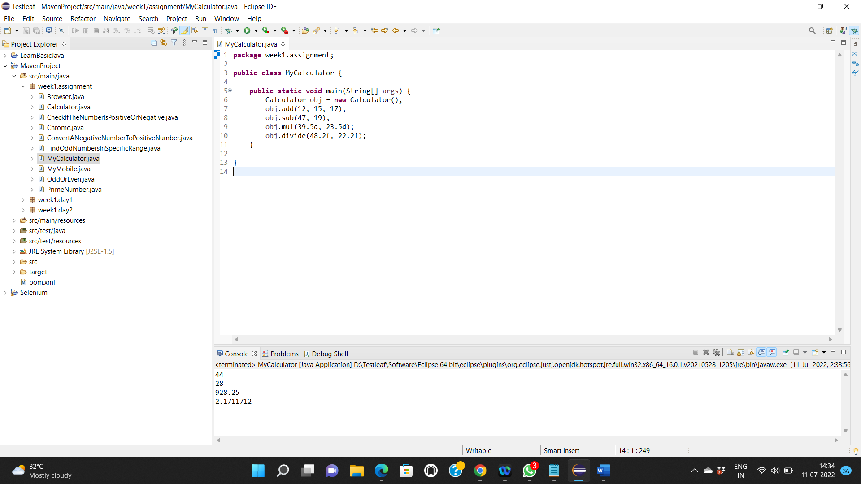

Assignment 4: Print if the given number is odd or even

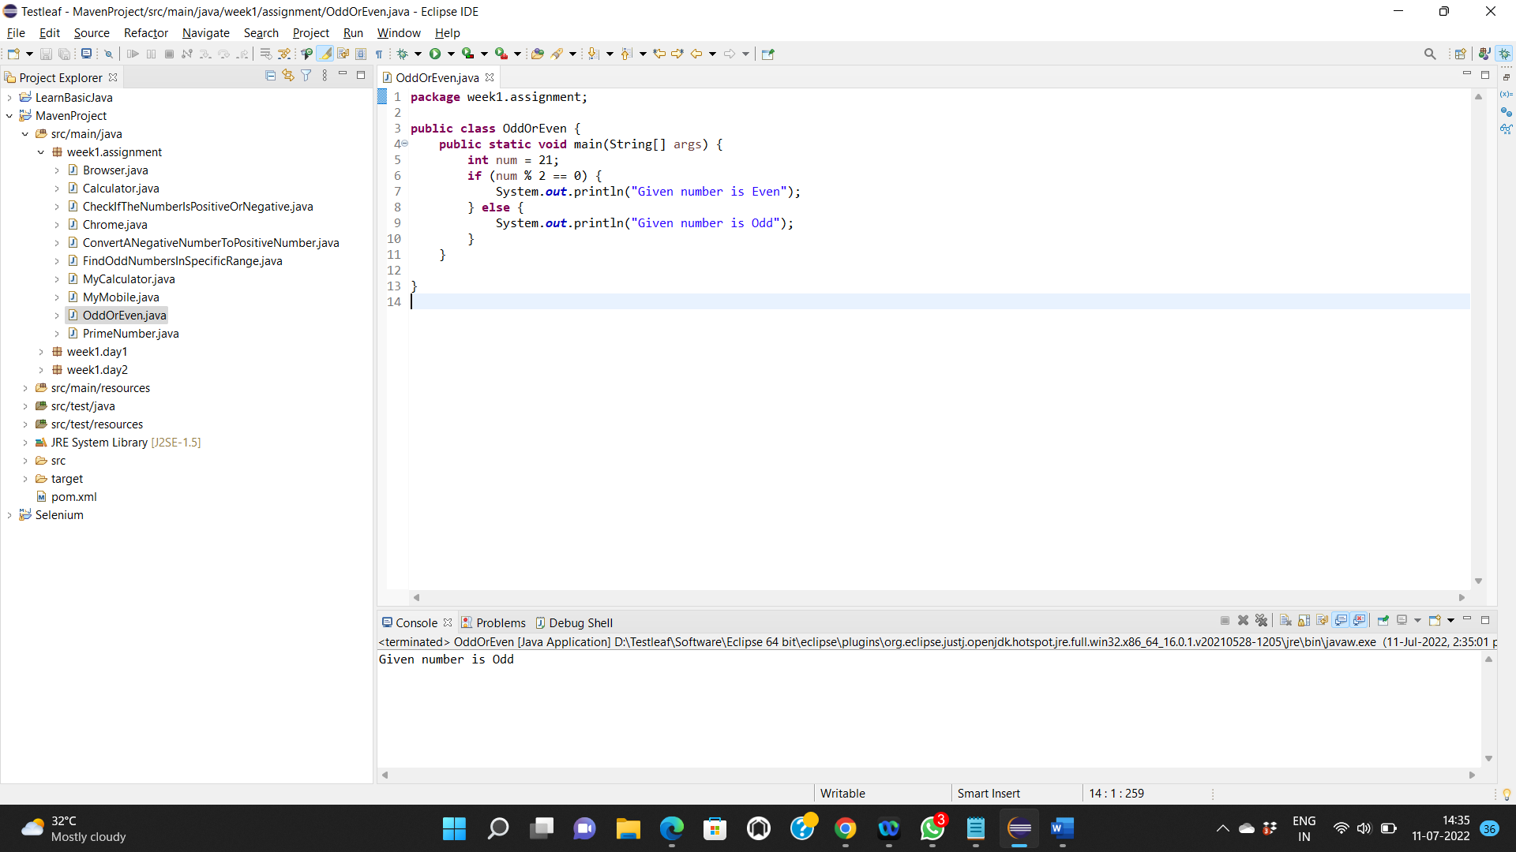

Assignment 5: To find whether a number is a Prime number or not

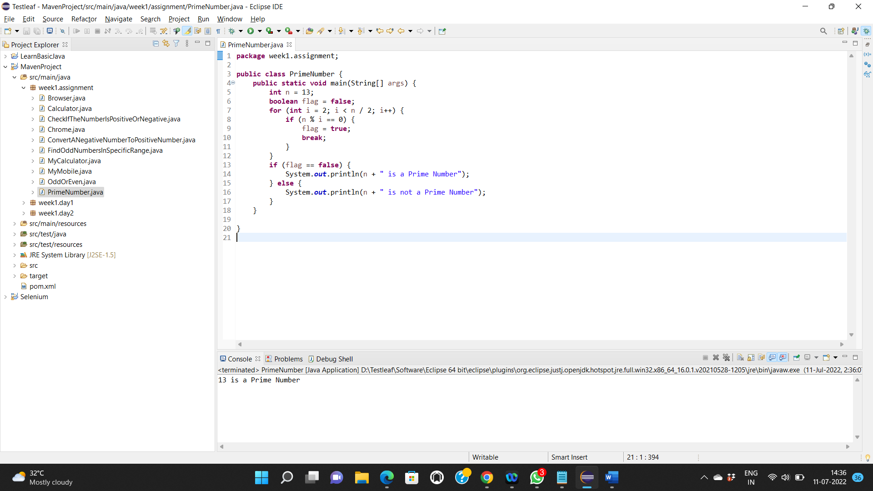

Assignment 6: Check If The Number Is Positive Or Negative

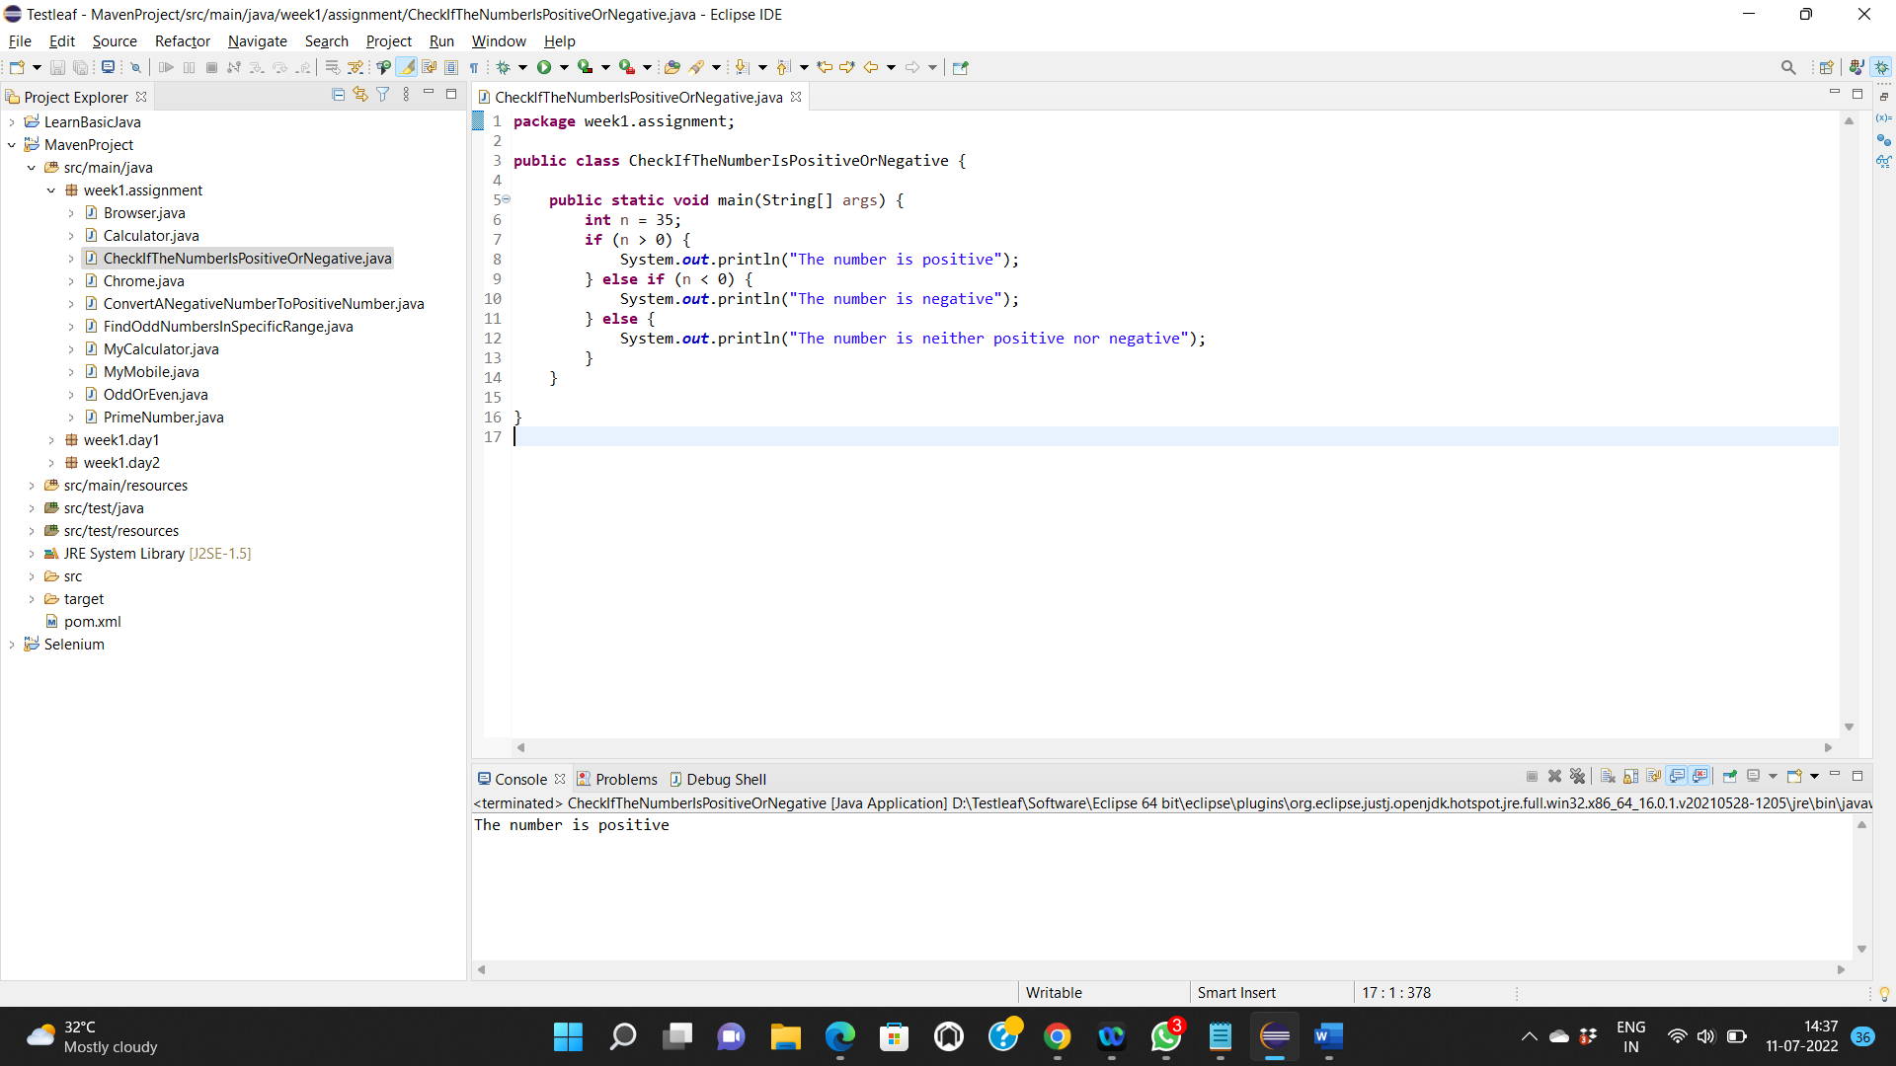

Assignment 7: Convert A Negative Number To Positive Number

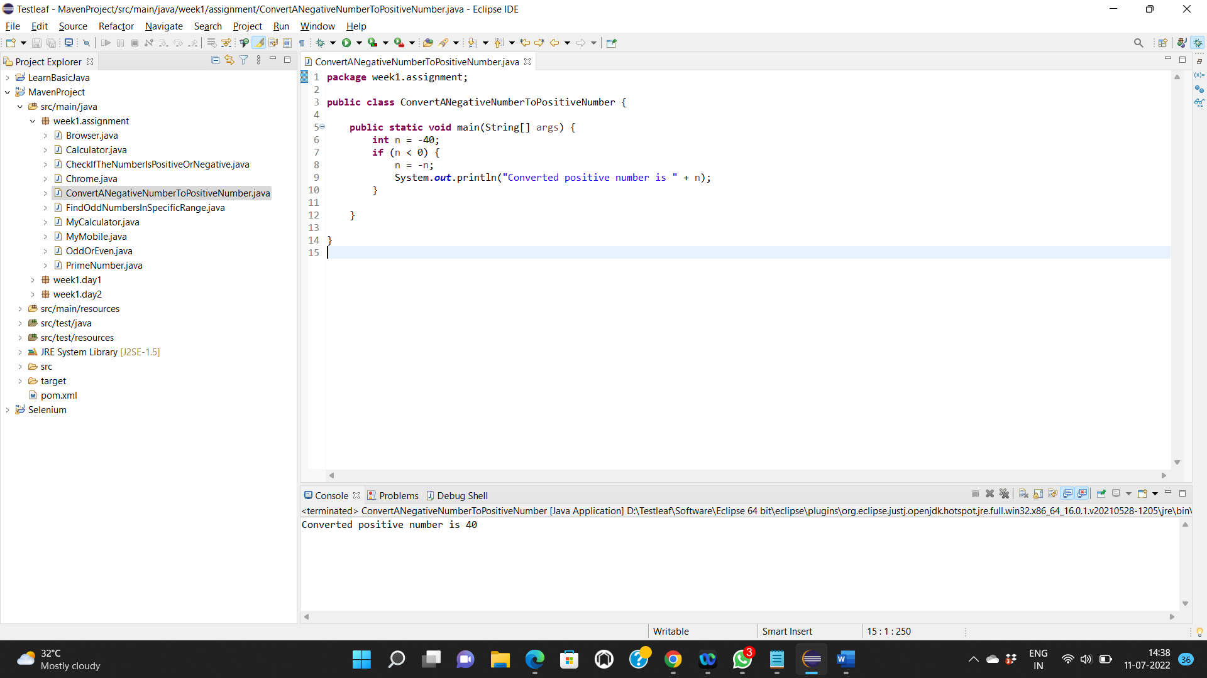

Assignment 8: Find the odd numbers in the specific range of numbers

